Assignment-35.1:

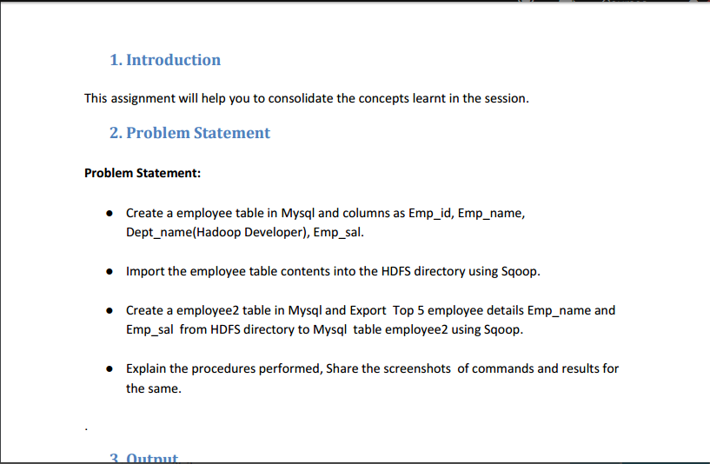

Creating a table named employee and inserting the values:

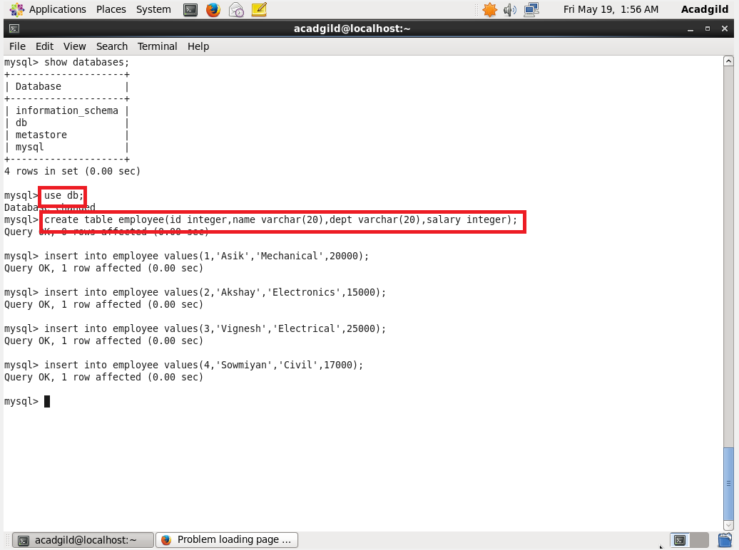

Displaying the contents of the table:

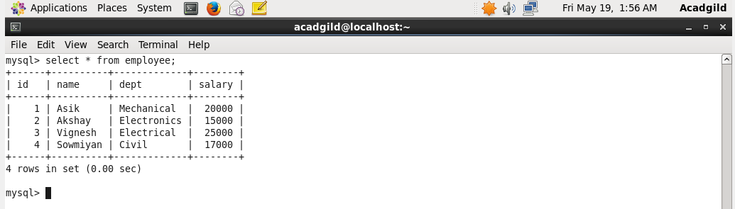

Importing the data from mysql to hdfs using the below command:

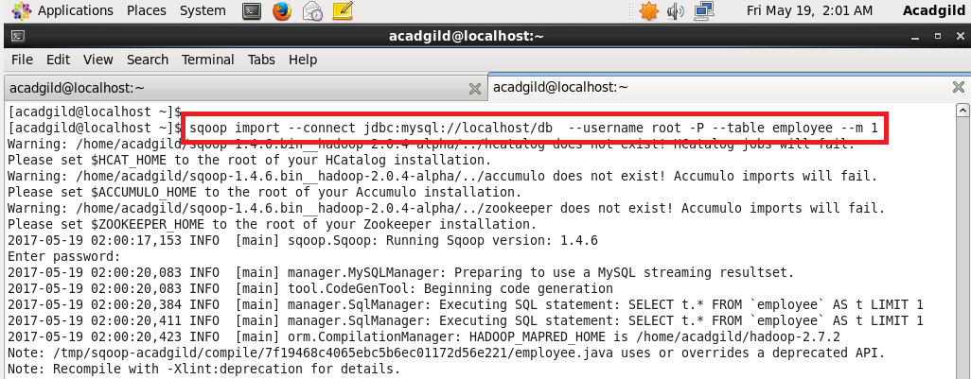

Data is imported successfully to hdfs:

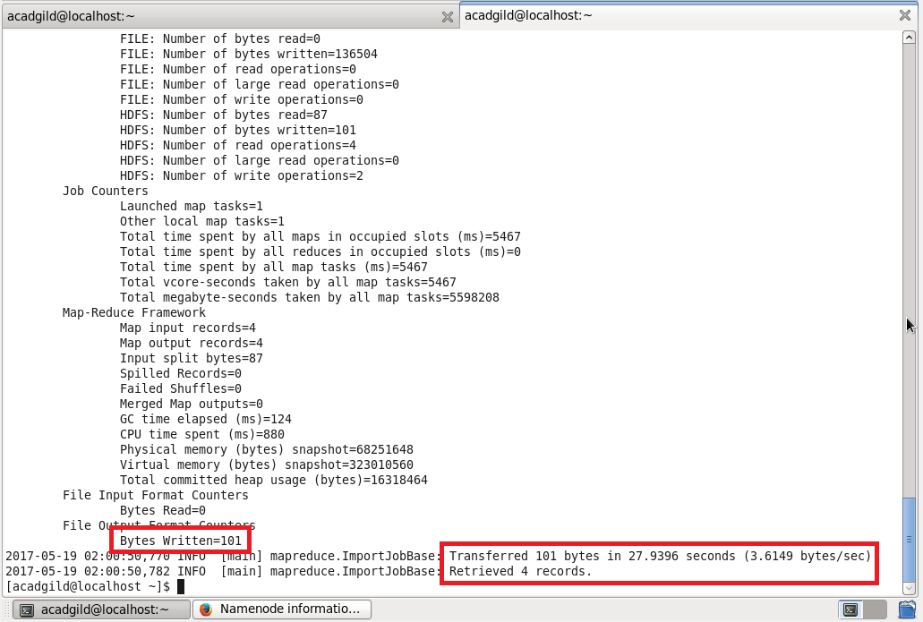

Checking whether the files are imported and displaying the contents of the employee.

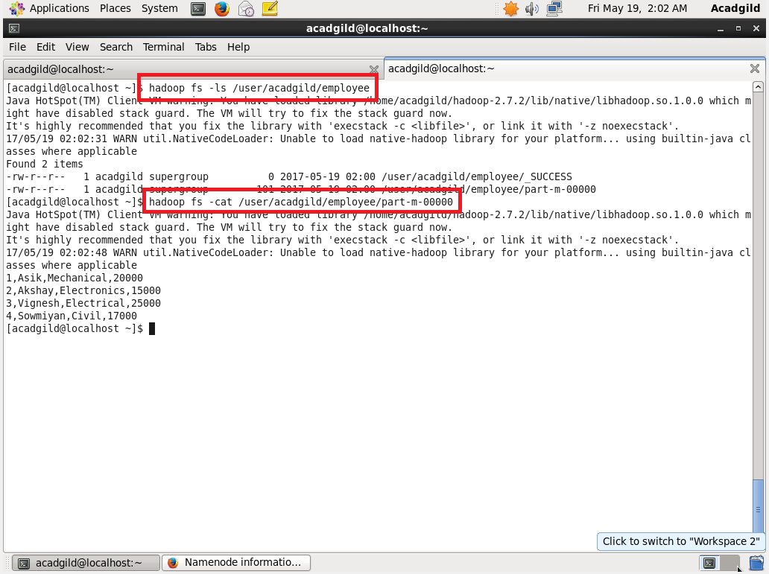

Creating another table named employee2 and keeping it empty because we have to export it from hdfs:

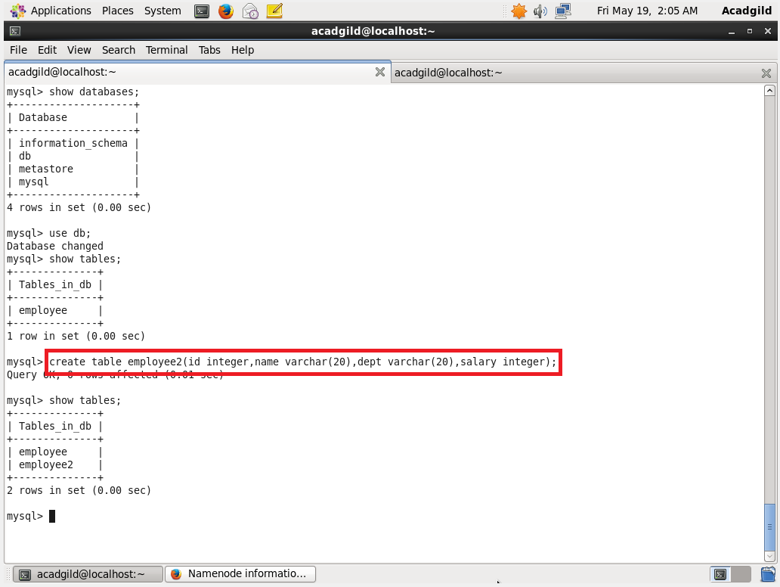

No data is present in employee2:

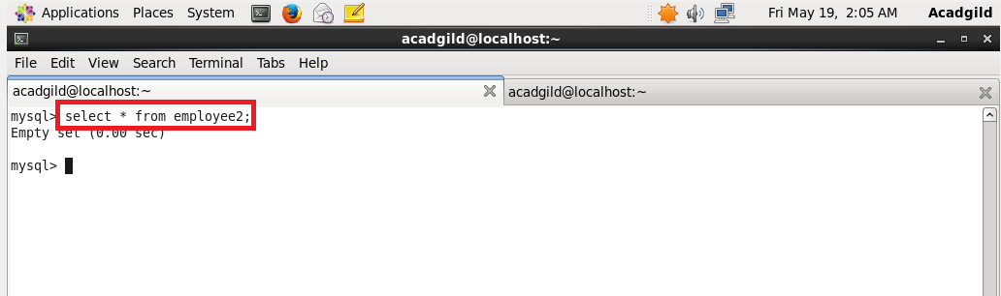

Exporting the table from hdfs to mysql:

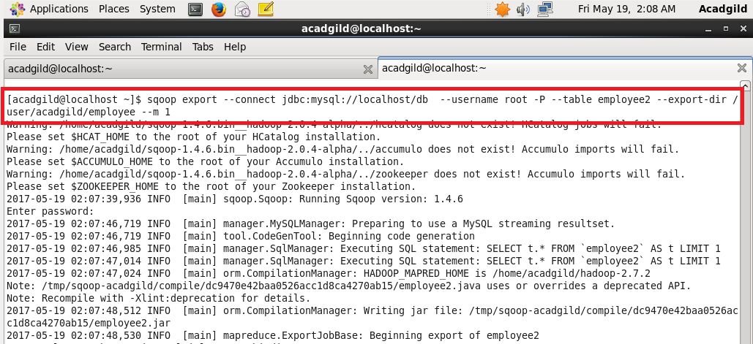

Data successfully exported:

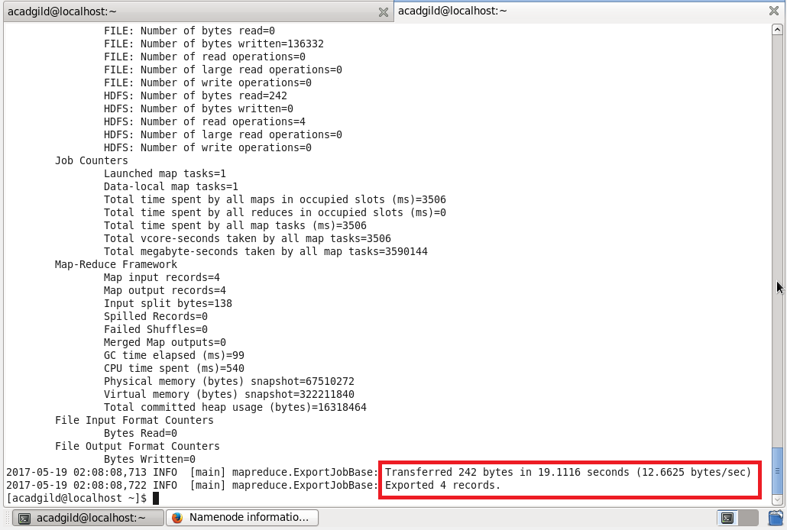

Displaying the contents of the exported table:

